**Session8**

**Secretariat and Directorates: organization, structure, and functions**

The Cabinet Secretariat functions directly under the Prime Minister. It is responsible for the administration of the Government of India and facilitate smooth functioning in Ministries/ Departments. It initiates and assists in decision-making in Government and ensures the coordination between ministries and generate unanimity. Secretariat also manages major crisis situations in the country and coordinating activities of various ministries in such a crisis.

**15.The State Secretariats are the main administrative centers of the state governments.**The state secretariat conducts the different functions that come under the jurisdiction of the state government, co-ordinates the activities of different departments of the state government and carries the responsibilities of implementing the fiscal, administrative and other policies implemented or adopted by the state government. (Source: https://www.importantindia.com/1707/state-secretariats-in-india/)

|  |
| --- |
| **The** |

**16. Directorates** The State Secretariats are the main administrative centers of the**;**they translate intoaction the policies that arc framed by the State Secretariat. Even though the terms 'Directorates' and 'Executive Agencies' are often used interchangeably,Directorates are but one type of executive agency. The Secretariat is concerned with the setting of the broader policies and goals of the state government while the responsibility for achieving those goals and executing those policies rests with the heads of the executive partments. **12. executive agencies are as a rule located outside the Secretariat and constitute distinct organizational entities**. A popular label to identify an executive agency is 'Directorate'. In many cases, the heads of the executive agencies are known as directors. Many examples of this could be cited; director of agriculture, director of animal husbandry, director of education, director of social welfare, director of transport, director of public health, director of town planning, and so on. However, other nomenclatures are also used to refer to the heads of the executive departments. Thus, the executive head of the department of police is known as the InspectorDirector General of Police; that of the jail department, the InspectorGeneral of jails; that of the forest department, the chief conservator of forests; that of the cooperative department, the registrar of cooperative societies; that of the sales tax department, the commissioner of sales tax; that of the irrigation department, the chief engineer (irrigation); that of the printing and stationery department, the controller and soforth. In other words, although in many cases, the heads of the executive departments arecalled Directors, they are also known by other names. (Source:

<http://egyankosh.ac.in/bitstream/123456789/19118/1/Unit-14.pdf>)

**Task 1: Draw a colorful Tree Diagram for the organization structure of the state secretariat and directorate. (10 Marks)**

|  |
| --- |
| **Debarghya Barik**  **RA2011026010022** |

**Ans: *Tree Diagram for the organization structure of Secretariat of Meghalaya:***

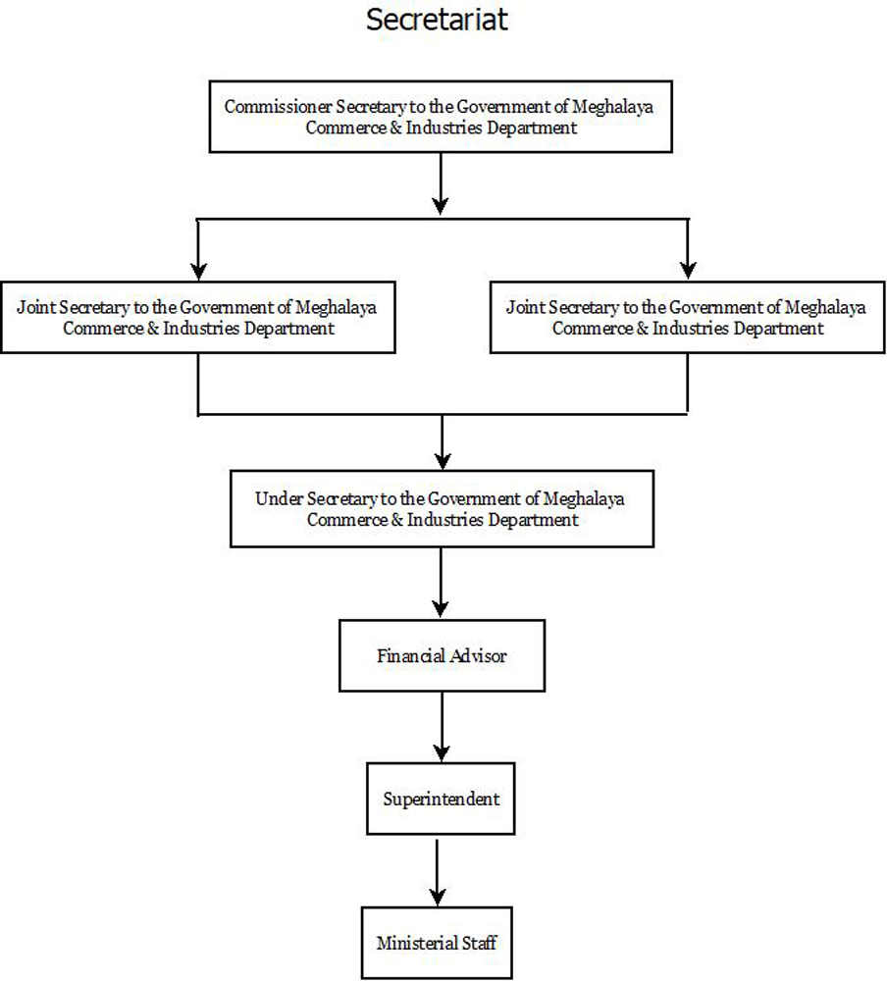

|  |
| --- |
| **Debarghya Barik**  **RA2011026010022** |

***Tree Diagram for the organization structure of directorate of Rajasthan:***



